1. Who is the customer who spent the most on rental movies? Return his/her customer id, firstname and the amount spent.

**Answer:**

Customer id is 13

First name: Karen

Amount spent - $ 11.99



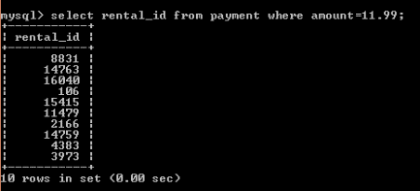





1. Give an interesting query of your own that is not already in the assignment. The query shouldinvolve at least two joins, HAVING clause and aggregation operation. Give the English explanationandtheanswer.

**Answer:**

SELECT customer_name, MIN (balance)from account GROUP By customer_name HAVING min(balance) > 10000

UNION

SELECT customer_name from loan;